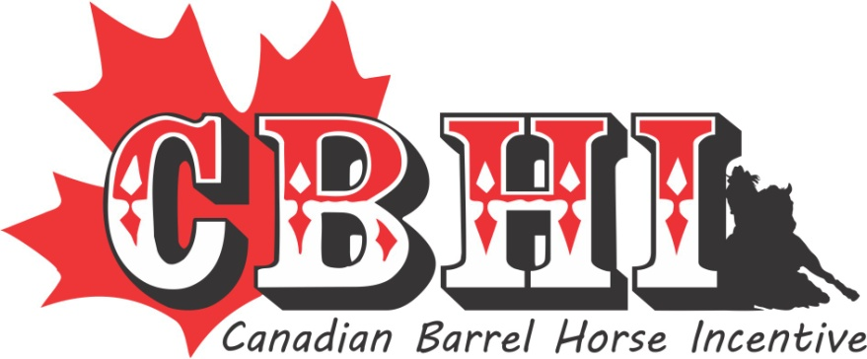

2024 ANNUAL NOMINATION FORM
Deadline for payment is Dec 1st (must be in the office)-Please keep a copy of this form your receipt.
* New Stallion’s advertising poster/flyer can be e-mailed/updated in a Jpeg format*
Payment must be in the office on Dec 1 to hold your SS spot including waiting list.
CANADIAN BARREL HORSE INCENTIVE 51314 RRD 22 Parkland County, Ab T7Y 2H8 e-mail -info@canadianbarrelincentive.com

Stallion Name:______________________________________________________________

Owner(s):_________________________________________________________________

Address:__________________________________________________________________

City/Province:______________________________________________________________

Postal Code:________________ Phone # (s) ____________________________________

E-mail:____________________________________________________________________

Nomination Fees:
Partial- Stallions without offspring of competition age &/or are not competing themselves | $250
Full- Stallions with offspring of competition age &/or are competing themselves. | $500
Deceased- Stallions with no frozen semen. | $250
Worker/Volunteer fee -$25 per stallion | $25 | $25
* Worker/Volunteer fee is to offset help that we have to hire to make our events run smoothly. TOTAL

Signature:__________________________________________________
(By signing this you confirm that you understand the difference between the 3 payment choices - no refunds)

Please circle below if this is a new stallion to the program: 1. You wish to be placed on the Super Stakes waiting list or 2. Not interested in the Super Stakes

Please check which area you would like to help with: You can contact the office or a director to see what any of the below entails.
Horse Sale
Provincial Event
Year End (audit)
Sponsorship
Ponoka Event
Bylaws/Rules
Live Stream

